CRYSTALGROUP

**FPT ACADEMY INTERNATIONAL**

**FPT – APTECH COMPUTER EDUCATION**

Design Document

Faculty: Ms Dao Ngoc Anh

Batch no: T1.2103.E1

Group no.: 4

Students: Full name Roll no.

|  |  |  |
| --- | --- | --- |
| 1 | Le Huu Thang (leader) | Student1302889 |
| 2 | Dang Chau Nhat Truong | Student1309638 |
| 3 | Ho Nhat Nam | Student1309634 |
| 4 | Nguyen Tien Dung | Student1309004 |

# MAY - 2021

**This is to certify that**

**Mr:**

Le Huu Thang

Dang Chau Nhat Truong

Ho Nhat Nam

Nguyen Tien Dung

**has successfully designed & developed**

eProject: crystal.com Website

**Submitted by:**

Le Huu Thang

**Date of issue:**

22-May-2021

**Authorised Signature:**

**ACKNOWLEDGEMENT**

This project consumed huge amount of work and dedication. Still, implementation would not have been possible if we did not have a support of many individuals. Therefore we would like to extend our sincere gratitude to all of them.

First of all, we would like to express my special thanks of gratitude to my teacher (Đào Ngọc Anh) who supported us to do this wonderful project on the topic (Crystal). She also helped us in doing a lot of researches and we had a chance to know about so many new things.

Finally we would also like to thank my parents and friends who helped me a lot in finalizing this project within the limited time frame.

**SYNOPSIS**

Crystal.com is a website which provides information about various types of crystal: diamond, amber, amethyst etc.

Crystal.com helps users who take care of crystal the opportunity to know more information about many kinds of them. All of the information is well organized and put into categories so it is very easy to search for and not time-consuming. In addition, Crystal.com also provides users with more information about the usefulness of various kinds of crystal that can affect people’s health.

Crystal.com also allows users to give feedback about their feeling or complain about crystal products. Users can select and read detail information about which crystal that they are interested.

**PROBLEM STATEMENT**

Having read the project specifications, our team members realize that there are problems and difficulties which may interfere the users’ experience. In order to make the most precise decision and look for the best solution to tackle this, each developer has to consider the following querries thoroughly:

1. How many categories are enough?
2. How many crystals should be display on a page when they are grouped into categories?
3. What information should be displayed on the homepage?
4. How can the users interact with the website?
5. How should the information about the crystals be shown on the page?

The website is to be developed for the Windows Platform using HTML5, JavaScript and Geolocation. The site should work well in all leading browsers including Chrome, IE, Firefox etc.

**REQUIREMENT SPECIFICATIONS**

The Web site is to be created based on the following requirements.

There should be pages as mentioned below

1. Home
2. About Us
3. Special Offers
4. New Arrival
5. Products
6. Contact Us
7. The Home Page should be created making use of Sections with a suitable logo, the header section can be added which will show images of various products.
8. The site must contain the links to navigate through any category for the information.
9. The site should display a menu which will contain the options for brief introduction about the various products available, location of the shop and any other information if required.
10. The information should be categorized according to the various crystals like if a User wants to see only “Diamond/Amber/Amethyst etc” products then he/she can click on a Link/button/menu etc and can see only that crystal products.
11. When a user selects any particular crystal, a list of all the products for that crystal will be displayed
12. A brief summary of features of the product should be displayed on the Web Page along with the picture but detailed Features should be stored in Individual Word documents which can be downloaded or viewed by the User who wishes to see the same.
13. The user should also be able to compare the various products
14. There should be a “Contact Us” page which will have the Address of the Company which should be displayed using GeoLocation API (eg. GoogleMaps) and the email address which when clicked will invoke the local mail client from where they can send an email.

**SCOPE OF WORK:**

After having a thorough discussion among members of the team, decision has been made to point out requirements which need to be developed:

1. All products are grouped into 4 categories.(Diamond, Amber, Agate, and Quartz).
2. Homepages will show menu options for product, about us, contact us and information about the special offer and new arrival crystals.
3. User can give feedback and download file from the website for more detail information about the product which you like.
4. Main features and price of the Products will be presented on the webpage with pictures.

**Hardware/ Software Requirements**

**Hardware**

* A minimum computer system that will help you access all the tools in the courses is a Pentium 166 or better.
* 64 Megabytes of RAM or better.

**Software**

* Notepad/HTML editor.
* Dreamweaver.
* IE 5.0/ Netscape 6.0.

**TASK SHEET REVIEW 1**

|  |  |  |  |  |  |  |  |
| --- | --- | --- | --- | --- | --- | --- | --- |
| ***Project Ref. No:***  ***Crystal*** | | **Project Title:** | **Activity plan prepare by:** | **Date of preparation of activity plan:** | | | |
| **Sr.no.** | **Task** | **Actual start date:** | **Actual days** | **Team mate name** | **status** |
| 1 | Acknowledgement | *Crystal* | Thang | 21/05/2021 | 1 | Truong | completed |
| 2 | Synopsis | Thang |
| 3 | Problem statement | Nam |
| 4 | Requirement specification | Dung |
| 5 | Hardware/Software Requirement | Thang |
| 6 | Task Sheet | Thang |

|  |  |
| --- | --- |
| **Date:** | |
| Signature of Instructor:  **Dao Ngoc Anh** | Signature of Team Leader:  **Le Huu Thang** |

**SITE MAP:**

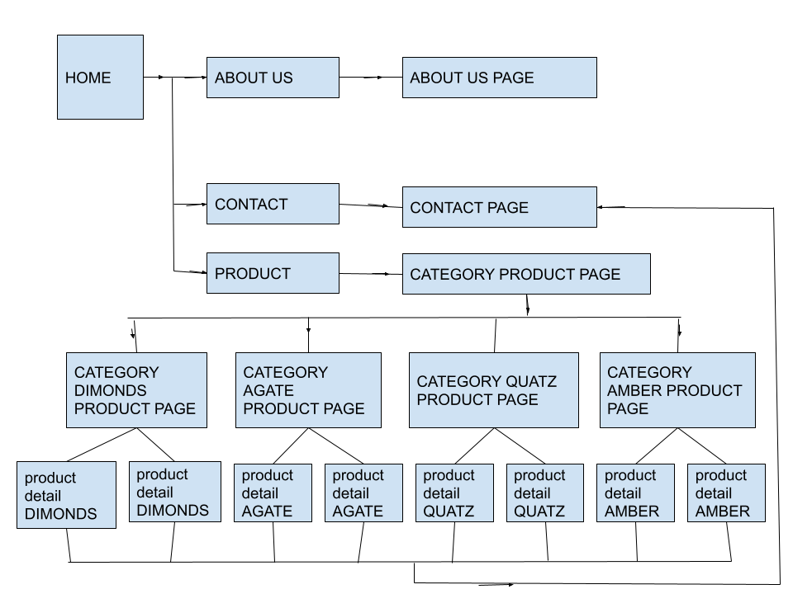

COMPARE PAGE

**STRUCTURE OF THE EACH WEBPAGE:**

**1/ ABOUT US:**

LOGO

MAIN MENU

FOOTER

COMPANY’S BACKGROUND

**2/ PRODUCT:**

LOGO

MAIN MENU

FOOTER

CATEGORY 1

CATEGORY 2

CATEGORY 3

CATEGORY 4

**3/ HOME:**

|  |
| --- |
| **LOGO** |

|  |
| --- |
| **MAIN MENU** |

|  |
| --- |
| IMAGE OF NEW ARRIVAL PRODUCTS |

|  |  |  |  |  |  |  |  |
| --- | --- | --- | --- | --- | --- | --- | --- |
| **SPECIAL OFFERS**   |  |  |  |  |  |  | | --- | --- | --- | --- | --- | --- | | IMAGE | IMAGE | IMAGE | IMAGE | IMAGE | IMAGE |  |  | | --- | | **SEE MORE** | |

FOOTER

**4/ CATEGORY PRODUCT PAGE:**

LOGO

MAIN MENU

|  |  |  |
| --- | --- | --- |
| PRODUCT IMAGE | CATEGORY THẠCH ANH  BRIEF INFORMATION     |  | | --- | | VIEW DETAIL | |

|  |  |  |
| --- | --- | --- |
| CATEGORY KIM CƯƠNG  BRIEF INFORMATION   |  | | --- | | VIEW DETAIL | | PRODUCT IMAGE |

|  |  |  |
| --- | --- | --- |
| PRODUCT IMAGE | CATEGORY MÃ NÃO  BRIEF INFORMATION   |  | | --- | | VIEW DETAIL | |

|  |  |  |
| --- | --- | --- |
| CATEGORY KIM CƯƠNG  BRIEF INFORMATION   |  | | --- | | VIEW DETAIL | | PRODUCT IMAGE |

FOOTER

**5/ PRODUCT OF EACH CATEGORY:**

LOGO

MAIN MENU

FOOTER

PRODUCT INFORMATION

PRODUCT IMAGE

DOWNLOAD DETAIL INFORMATION

CONTACT TO BUY

COMPARE

**6/CONTACT:**

Logo

Main menu

Title

|  |  |
| --- | --- |
| Contact form | Google map |
| Full name: | **Map** |
| Phone number: |
| Email: |
| Address: |
| Content: |
| Exit  Send |

Member no1Member no2Member no3

image

Name & information

image

image

Name & information

Name & information

Footer

7/COMPARE PAGE:

PRODUCT 2

LOGO

MAIN MENU

FOOTER

PRODUCT 1

**Tasksheet review 2**

|  |  |  |  |  |  |  |  |
| --- | --- | --- | --- | --- | --- | --- | --- |
| ***Project Ref***  ***Crystal*** | | **Project Title:** | **Activity plan prepare by:** | **Date of preparation of activity plan:** | | | |
| **No.** | **Task** | **Actual start date:** | **Actual days** | **Team mate name** | **status** |
| 1 | Site map | *Crystal* | Thang | 22/5/2021 | 5 | Nam | completed |
| 2 | Mock of website | Thang, Truong, Nam,Dung |
| Homepage | Nam |
| Product | Thang |
| Category product page | Nam |
| Contact | Dung |
| About us | Truong |
| Product of each category | Thang |
| Compare page | Dung |
| 3 | Task Sheet | Thang |

|  |  |
| --- | --- |
| **Date:** | |
| Signature of Instructor:    **Dao Ngoc Anh** | Signature of Team Leader:    **Le Huu Thang** |

**1/HOME:**

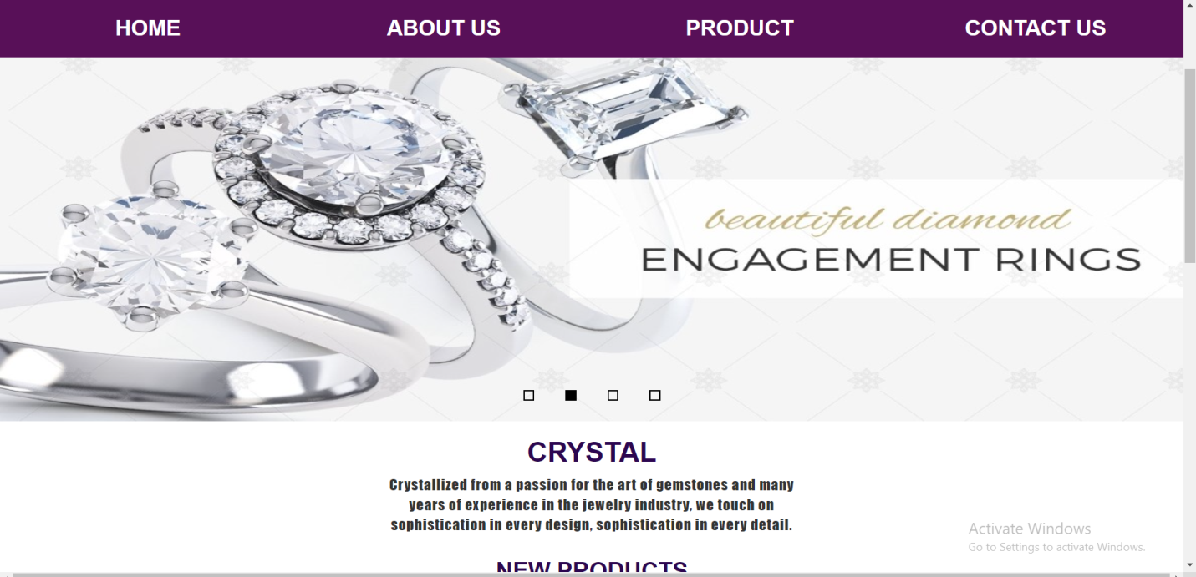

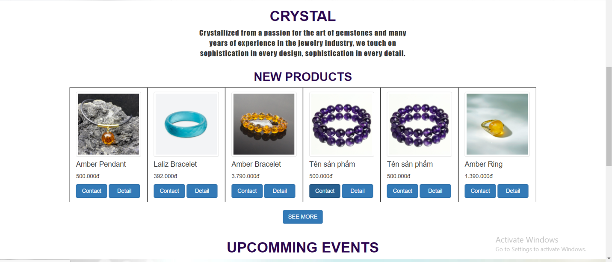

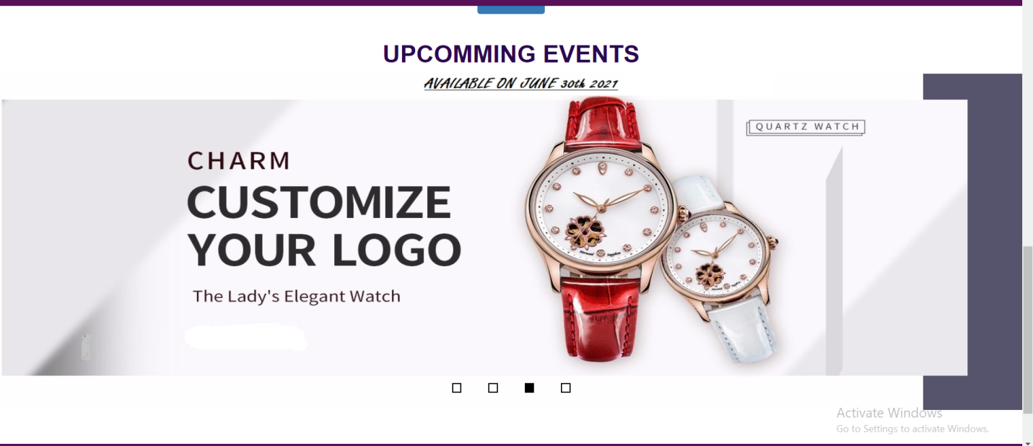

In our homepage, we will introduce about our new products and special offers. Customers can take a look at products which they care. Then, they can click to those products to move to a detail product page which they can see full information.

**2/ABOUT US:**

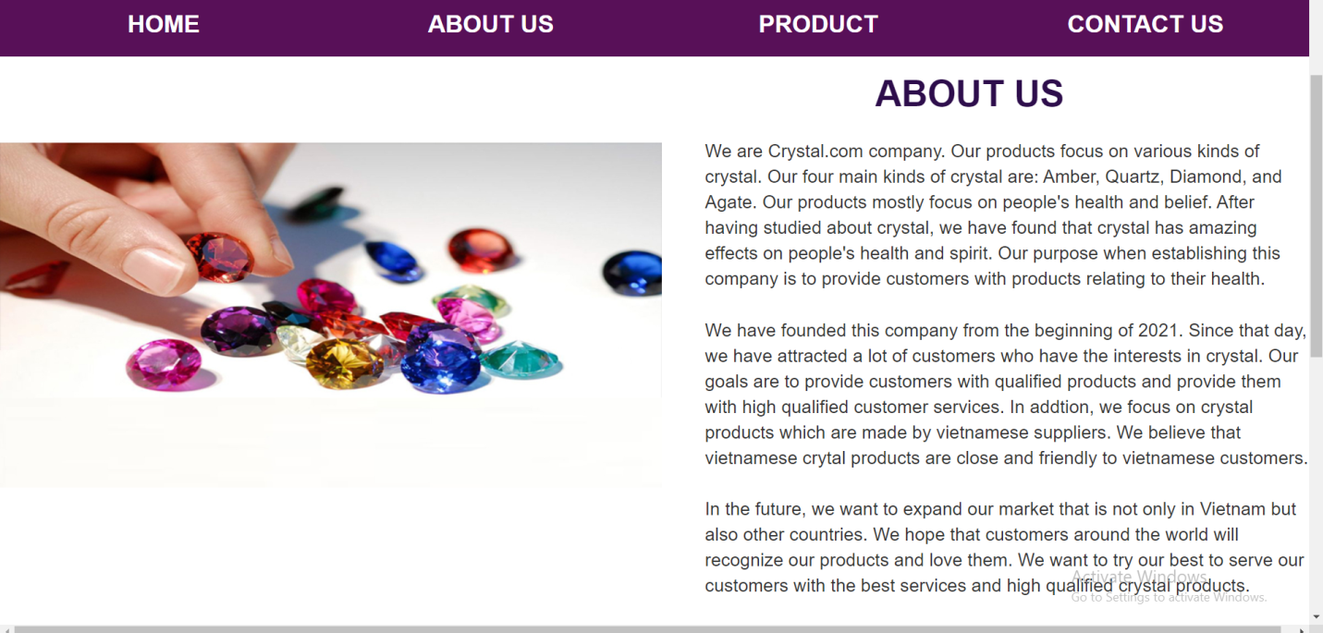

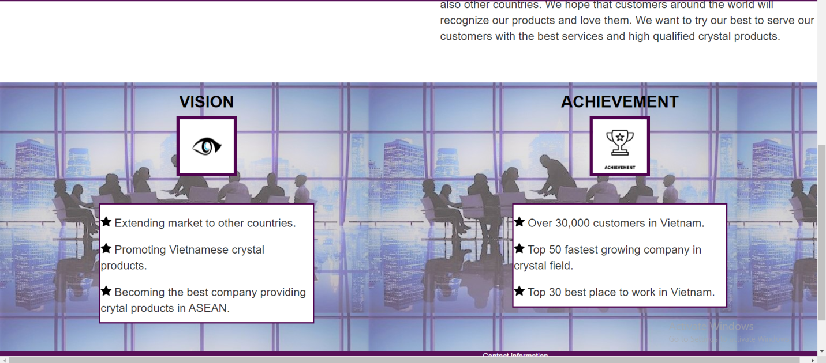

In about us page, we want to introduce about crystal.com company which customers can take a reference about the company. This page provides customers with company information like: company’s products, company’s establishment, and company’s goals.

**3/PRODUCT:**

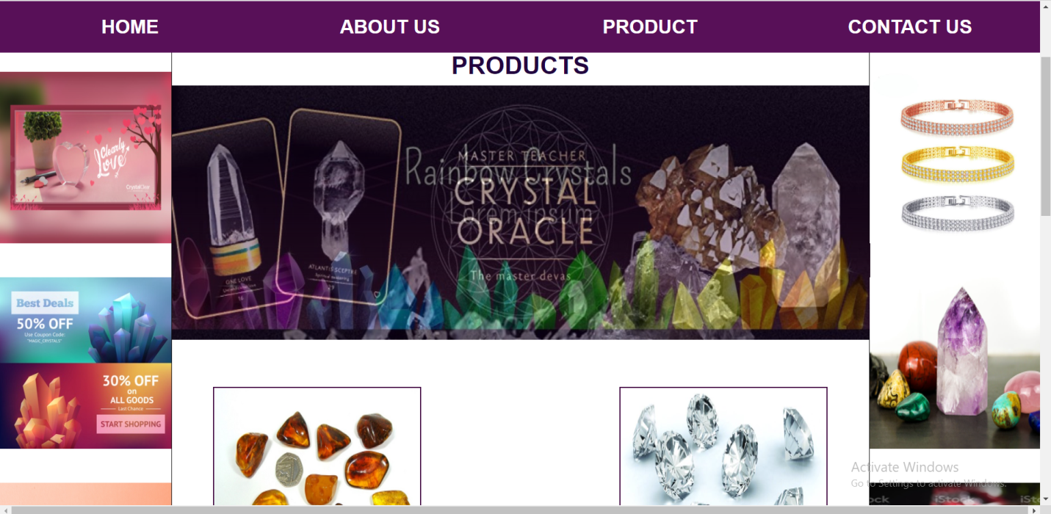

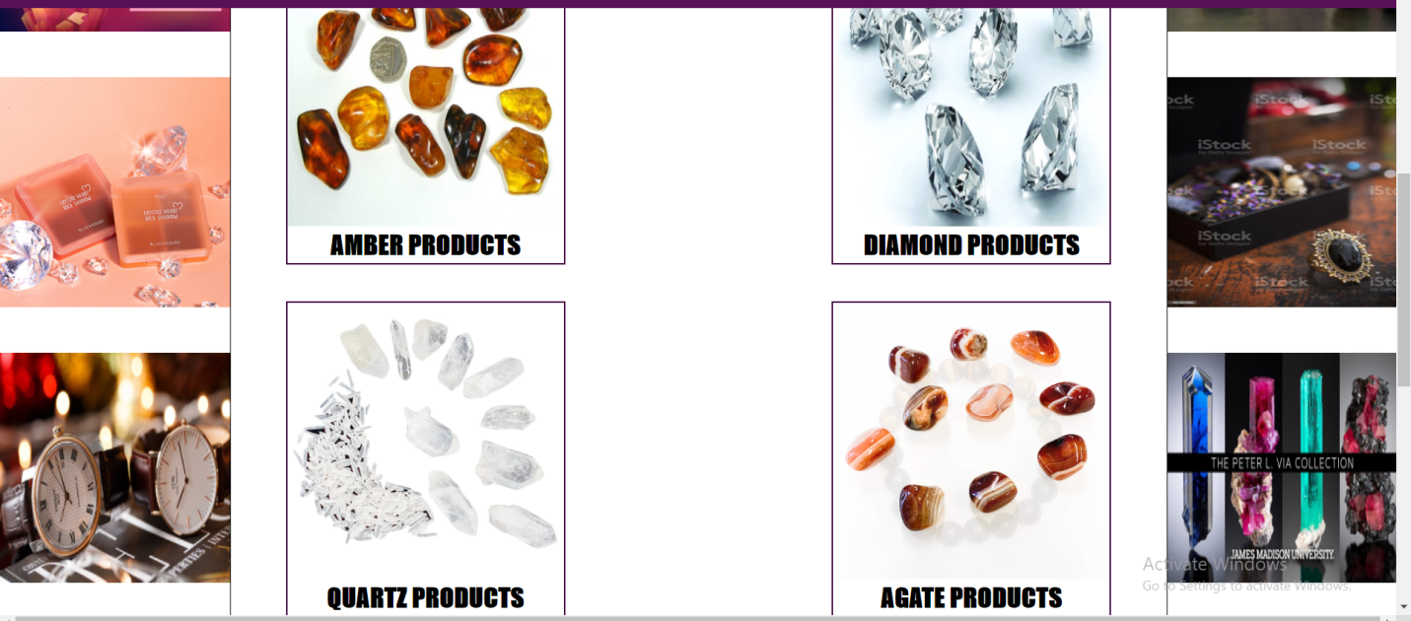

In our product page, we will introduce about company’s main four kinds of crystal. They are: amber, agate, diamond, and quartz. Customers can click on the category of crystal which they like to see products of that kind of crystal.

**4/ CONTACT**

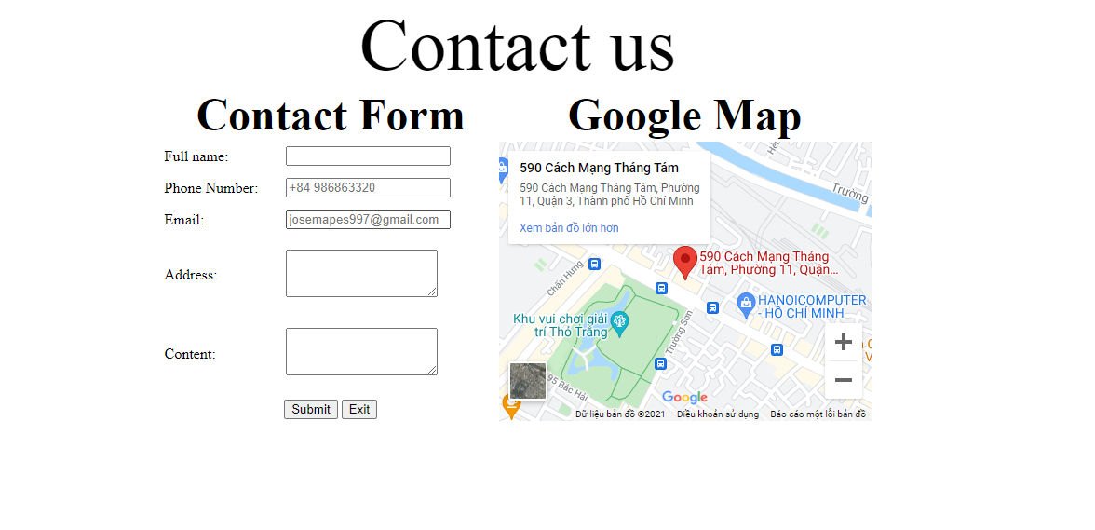

In our contact page, customers can see company’s address. In addition, if customers have any question or problem with company’s services or products, they can fill in the contact form to let the company know their problems.

**5/CATEGORY PRODUCT:**

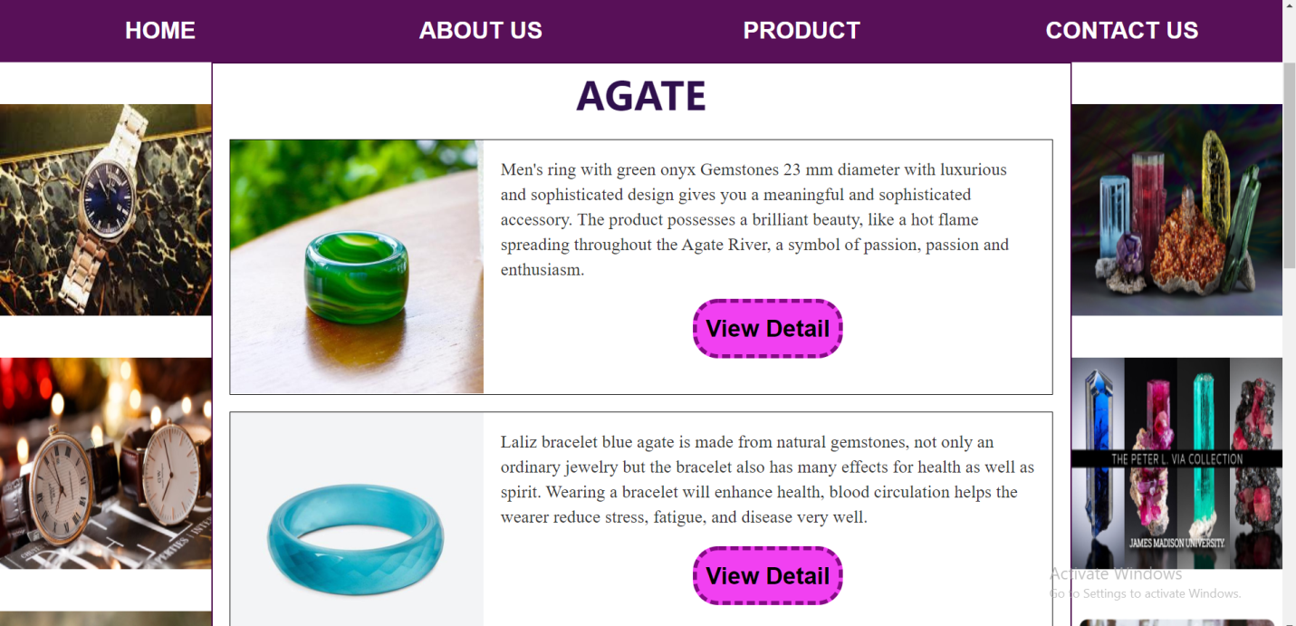

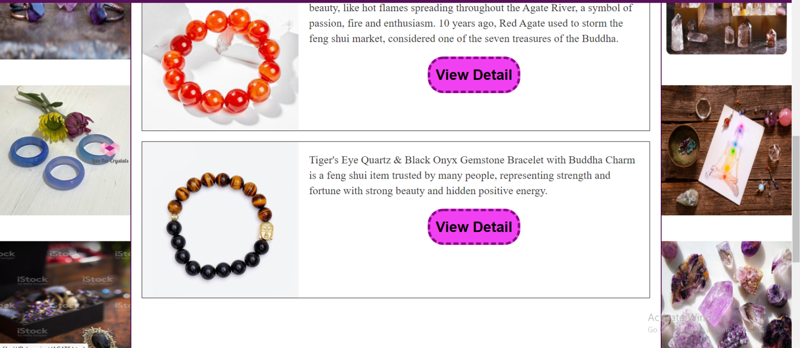

Each category of crystal will have its own category products page. Customers can see products of each kind of crystal in this page. In addition, customers can click on the view detail button to see the detail information about the product which they are interested in.

**6/PRODUCT DETAIL:**

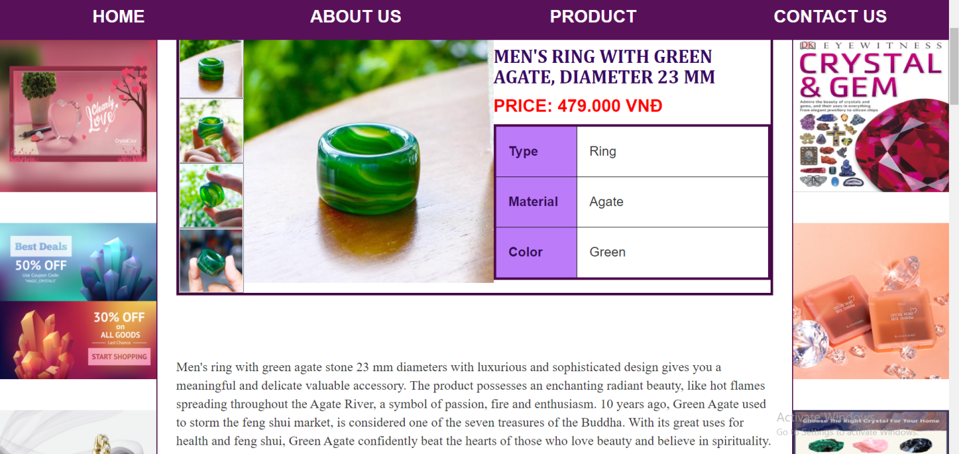

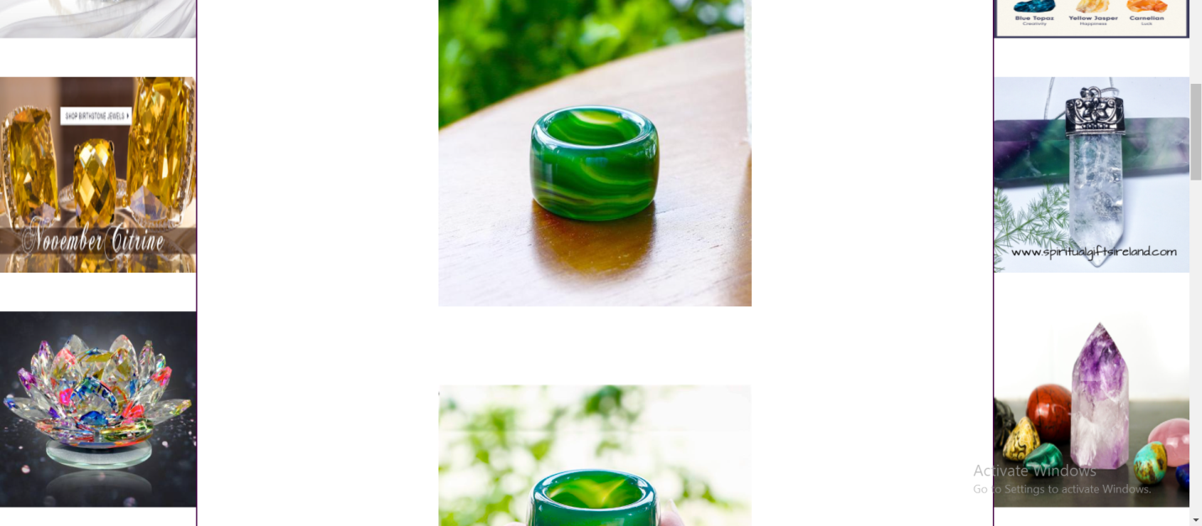

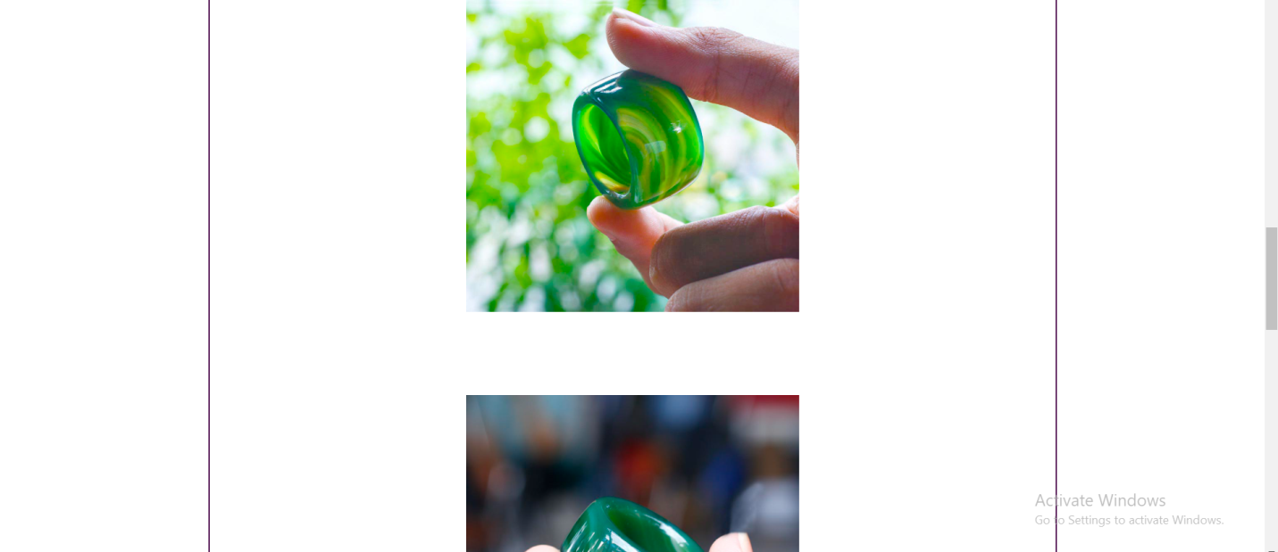

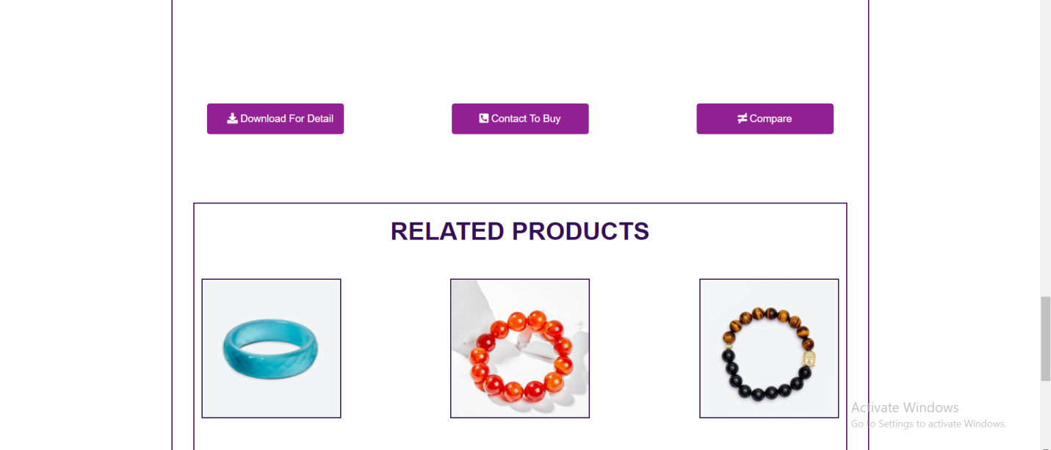

In product detail page, it will give customers a brief summary of the product. Customers can see the price, color, appearance, and material of the product. Moreover, customers can read a brief description of the product. Customers can also read full detail information by clicking on the download for detail button to download file word which covers all information about the product. In addition, customers can contact to buy the product if they like it, and compare the product with other products.

**7/COMPARE:**

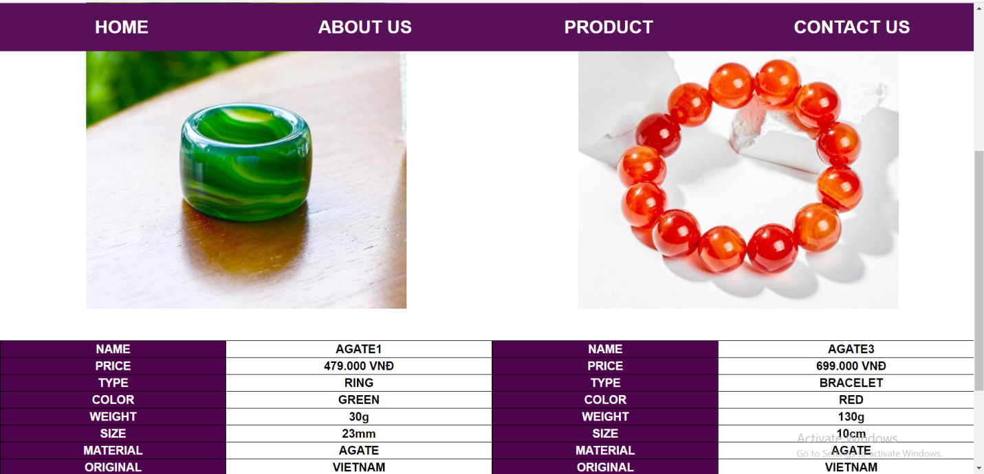

In compare page, customers can compare products of the same category. This page will display parameters of 2 products to help customer can easily to compare.

**Task sheet review 3**

|  |  |  |  |  |  |  |  |
| --- | --- | --- | --- | --- | --- | --- | --- |
| ***Project Ref:***  ***Cystal.com*** | | **Project Title:** | **Activity plan prepare by:** | **Date of preparation of activity plan:** | | | |
| **Sr.no.** | **Task** | **Actual start date:** | **Actual days** | **Team mate name** | **status** |
| 1 | Homepage | *Crystal* | Thang | 1/6/2021 | 14 | Nam, Thang | completed |
| 2 | About us | Truong | completed |
| 3 | Product | Thang | completed |
| 4 | Contact | Dung | completed |
| 5 | Category product | Thang | completed |
| 6 | Product detail | Thang | completed |
| 7 | Compare |  |  |  |  | Dung | completed |

|  |  |
| --- | --- |
| **Date:** | |
| Signature of Instructor:    **Dao Ngoc Anh** | Signature of Team Leader:    **Le Huu Thang** |